# Corporate culture: value, sense of ethics, social responsibility

# Group1 Talk about corporate culture 企业文化

## Words

* Xxx boil down to sth/doing sth: (xxx问题) 都归结到 e.g 归根结底还是利润 Everything boils down to profits. Eg. No need to argue at all. Everything boils down to money.
* 利润第一: Profits come first.
* （作为对朋友的）告别语: some **parting** words; a **parting** statement
* big money machine/cash cow
* extreme end 最顶端， high-end, low-end
* Unfortunately, I got 10% **pay-cut** 降薪this year.
* Sense of ethics 道德观， 伦理意识 .e.g 我自认是一个诚实有道德的人 I think of myself as an honest and ethical person.
* Lay off sb, lay sb. Off => N. layoff e.g. During the recession, they were forced to ***lay off employees***. E.g. Even though as debts **rose**, they avoided layoffs and pay cuts.
* 即便是债务增加，他们还是避免裁员和降薪
* A cleaner approach
* Give back to sb. 回报
* 对我来说，环境是**头等大事**: The **No. 1 thing** for me is the environment
* 我**坚信**要做一个有爱心的人 I **firmly** believe in being a **caring** and **considerate/thoughtful** person.
* 人人为我，我为人人 **Everyone is for everyone else**. And we think of ourselves as a big family.

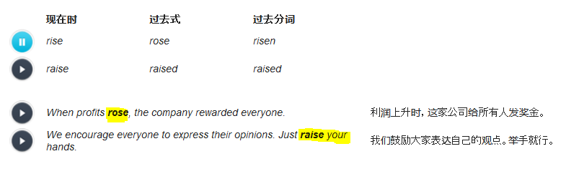

* Rise, rose, risen: **sth rises** (不及物动词 without any objective) e.g. Sun rises.
* Raise, raised, raised: **raise sth**, e.g. raise your hands 及物动词 (must followeed by an objective)
* lie: lie lay lain
* lay laid laid

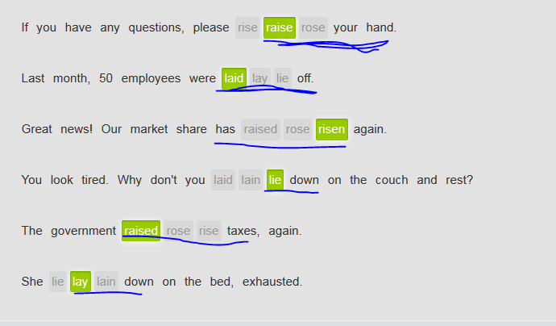

## Tapescript

What are your thoughts about corporate **social responsibility**, and what guidance you can give to our students as **a parting statement** /or **some parting words**作为对朋友的告别语?

Yeah. My thoughts would be more on **the extreme end** for social responsibility. I just grew up with a **sense of ethics** – very strong sense of it from my dad. And it was much more important to me in my life, my happiness, than, you know, anything that business **ever** brought me.

Um, I always thought, when I worked in Hewlett-Packard, I was so strongly influenced by the early, it was a different Helwete-Packard than today. The HP values, and anybody could communicate at any level, and stockrooms of parts were not locked up from engineers that could use them, ever for devices of their own design. And um, it was like we thought of ourselves, as a family.

When there was a horrible economic **recession**, HP was supposed to **lay off** 10 percentage of its employees. Instead of **laying them off**, everyone took a 10 percent **pay cut**降薪. Nobody was fired, put on the street and shout “You don’t have a job to support your family anymore”. And I really believed that the ethical responsibility in the world, like, just, you know, being **a caring/thoughtful/considerate person** for those who don’t have a just **No. 1 thing头等大事** for me.

One of the reasons, you know, I like teachers so much that I married a teacher, and I’m a teacher now. So you know, **obviously**, the profits come first, which is the way we run our business **in this day and age (在当今这个年代).** But boys, when you’re working on something, you can just think “Is there any step I could just take a little extra time, that really doesn’t show, and **motivated** me even more about what’ I’m doing?” It **comes up with** a little **cleaner approach**: maybe uses a little less energy, little puts, a little bit less, for a least my project. You know, costs and it all **boils down to** making thing for less cost.

Um, if once you have this big money machine/**cash cow**, earned a lot of money. Well, a small percentage, or some reasonable percentage of these money should really go to the surrounding communities. That’s where you came from. For example, I came from my schools. I wanna **give some funding back to** my schools. I came from, you know, various people in my life that were very important to me and would want to give them back, and so it’s good when a company thinks that way and actually does it.

## Tapescript

BOB**: In summary,** because profits r**ose** by 2 percent last month, there will be no **layoffs** or **pay cuts** . But we still have a lot of work to do. That's it, unless you have any questions. Just **raise your hand.** Alice?  
ALICE: Thanks, Bob. We'd talked about taking **a cleaner approach** in business process management. By how much do we expect cleaner business processes to cut operating costs?  
BOB: Well, I think Carol is the best person to answer that question. She has a note of all the facts and figures. Carol?  
TED: Oh, Carol just left.  
BOB: What happened?  
TED: Uh, I'm not sure. She told me she was going to **lie down** on the couch in the break room. Said something about not feeling well.

## Corporate culture – some remarkable points

* Being a **caring** and **considerate** person is part of the corporate culture. 做一个有爱心的人是一种公司文化。
* 我**坚信**要做一个有爱心的人 I **firmly** believe in being a **caring** and **considerate/thoughtful** person.
* 人人为我，我为人人 **Everyone is for everyone else**. And we **think of** ourselves as a big family.
* One employee can communicate with another at any level. 员工之间不分地位可以相互交流。
* What it **boils down to** is treating people fairly. 归根结底还是公正待人
* She has a strong **sense of ethics** and social responsibility. 她拥有很强的**道德观**和社会责任感
* Profits come first, but we **give back to回报** the community. 虽然利润第一，但是我们还是回报社区。

## 谈论 corporate culture 时，values、ethics 和 responsibility 等概念非常重要。

|  |  |  |
| --- | --- | --- |
|  | | |
|  | | |
| **value** 一词既能作名词，也能作动词。 | | |
|  | | |
|  |  |  |

|  |  |  |
| --- | --- | --- |
|  | *I was strongly influenced by the company's* ***values****.* | 我深受公司价值观的影响。 |
|  | *Managers always* ***value*** *passion.* | 经理人员始终看重热情。 |
|  | | |
| **value** 和 **responsibility** 可变为形容词。使用后缀 **-able** 或 **-ible**。 | | |
|  | | |
|  | *We feel that effective communication is most* ***valuable****.* | 我们认为，有效的沟通极为宝贵。 |
|  | *We are* ***responsible*** *for giving back to the community.* | 我们负有**回报社区的责**任。 |

|  |  |  |  |
| --- | --- | --- | --- |
| **ethics** 可变为形容词。请使用后缀 **-al**。 | | | |
|  | *I don't think that such extreme layoffs are* ***ethical****.* |  | 我认为如此大规模的裁员是不**道德的**。 |
|  | | | |
| 名词 **cut** 可用作动词，词形不变。 | | | |
|  | *They* ***cut*** *our pay by 10 percent during the recession.* |  | 他们在经济衰退时期削减了我们百分之十的工资。 |
|  | | | |
| 在动词 **surround** 后加上后缀 **-ing**，就构成了它的形容词 **surrounding**。 | | | |
|  | *Our company is part of the* ***surrounding*** *community, and we should be aware of that.* |  | 我们的公司是周围社区的一份子，这一点我们应该清楚。 |
|  |  |  |  |
| 动词 **lay off** 常用于过去式被动语态： | | | |
|  | *Thousands of employees* ***were laid off****.* |  | 数以千计的员工被解雇了。 |
|  | | | |
| **Lay off** 的名词形式为：**layoff**。 | | | |
|  | *Similot announced* ***layoffs*** *today.* |  | Similot 今天宣布了裁员。 |

## TapesScript

* I just applied a job in Apple. It’s a **wonderful** corporation.
* What do you like about it?
* Well, you know **the corporate culture**. I have a strong sense that they **think of** themselves as a family. There seems to be really good communication.
* It's great if you can talk freely to people **at any level.**
* **Exactly**. You know, what they did during the recession. They didn’t lay off anyone, instead, everyone got few **pay cuts.**
* You mean nobody got laid-off?
* No, they don’t.
* Sounds like they have a strong **sense of ethics**.
* Yeah. **I’m tired /weary of** working for the company that just takes advantage of their employees and environment and then doesn’t **give anything back** to the community.
* Right. I know profits come first, but social responsibility is important.
* I totally agree. That’s the I should join this company.
* And, as a corporation's profits rise, **the social responsibility** becomes even more important.
* Yeah, the social responsibility is the **No.1 thing** for me. At least I hope I can get the interview.
* Yeah, the place sounds great. I hope you get the job.

# Group2 Explaining your company’s structure

## Words

* forefront /ˈfɔːˌfrʌnt/   the forefront of something xx东西的前沿, (思考、关注的) 重心 [ the forefront of the IT technology; ]

1.N-SING If you are at **the forefront** of a campaign or other activity, you have a leading and influential position in it. (运动、活动的) 前沿 e.g. They have been at the forefront of the campaign for political change. 他们一直处于政治变革运动的前沿。e.g. 他们处于可持续发展的前沿 They're at **the forefront of** sustainable development.

Eg.g 在新公司，她的工作将处于生物技术的前沿 In her new company, she will be working at **the forefront of** biotechnology. Eg. IBM established the UX studio department, that works as the **forefront** of the global UX design.

2.N-SING If something is **at the forefront of people's minds** or **at the forefront of sb’s attention**, they think about it a lot because it is particularly important to them. (思考、关注的) 重心 e.g. The pension issue is exactly at the forefront of his mind nowadays. 养老金问题是他思考的重心 e.g. Finding a BF is exactly at the forefront my attention.

* 补偿你的 I’ll make it up to you. E.g. **I’m sorry, please give me a chance to make it up to you**. E.g. I'm sorry that our service was unsatisfactory, and I'll do my best to make it up to you (我们会尽力去补偿您）
* **assume the role of**

If someone assumes power or responsibility, they take power or responsibility. 接受 (权利、责任) e.g. Mr. Cross will **assume the role of** CEO with a team of four directors

|  |  |  |  |  |  |  |
| --- | --- | --- | --- | --- | --- | --- |
| **商务术语的前缀** | | | | | | |
|  | | | | | | |
| **re-** 和 **fore-** 等前缀改变它们所附单词的意义。 | | | | | | |
|  | | | | | | |
| **Re-** 意为 'again'。 | | | | | | |
|  | | | | | | |
|  | *The company wants to* ***rehire*** *me with a competitive benefits package.* | |  | 那家公司希望重新聘请我，给我提出了极具竞争力的福利待遇。 | | |
|  | *We're going to* ***relocate*** *the office to Stockholm, and establish factories and a distribution center in Copenhagen.* | |  | 我们打算把办公室前往斯德哥尔摩，在哥本哈根建厂，设立分销中心。 | | |
|  | *We need to* ***reorganize*** *the company to increase efficiency.* | |  | 我们需要重组公司，提高效率。 | | |
|  | *They* ***restructured*** *the company last year.* | |  | 他们去年对公司进行了改组。 | | |
| **Fore-** 可以指 'in front of' 或 'before'， **Forefront** 意思是领先其他所有人。 | | | | | | | |
|  | | | | | | | |
|  | | *Our company is at the* ***forefront*** *of sustainable energy.* | | |  | 我们公司处于可持续能源的前沿。 | |
|  | |  | | |  |  | |
| **Forecast** 意为 'to predict'。 | | | | | | | |
|  | | | | | | | |
|  | | *The CFO is* ***forecasting*** *an increase in profits.* | | |  | 这位首席财务官正在预测利润会有所上升。 | |

## Tapescript

* What do you want for me?
* Well, I want you to go back, just be with me. **We’re going global**. I cannot lose someone like you. I’d like to let you **assume the role of** LA director.
* What’s going to happen to you? Are you going to retire or?
* Um, funny. Well, I’ll be going to relocate in SH; and I’ll be involved in **starting up** a new office there. We’re establishing a department that is **the forefront前沿 of sustainable development**.
* Excuse me, Elizabeth? Are you kidding me? **You stabbed me in the back.** 背后中伤in the meeting last week. What do you expect me to do?
* I’m sorry, OK… I **screwed it up/messed it up**. I’m really sorry and I messed it up. If you gave me any chance, I will try my best to **make it up to you**补偿你的, giving your responsibilities that you’ve been asking for. I’m gonna let you reorganize the company structure. We’ll offer you a very **competitive package**.   
  Again**, I’m sorry, please give me a chance to make it up to you**.. *I'm gonna make you an offer that you can't refuse*

## ?Tapescript

http://ec.ef.com.cn/school/studyunit#school/2505ece3-f653-4a2f-9edb-1fc969b4bae8/2505ece3-f653-4a2f-9edb-1fc969b4bae8/c731165c-e272-4c96-8c62-794acc2cbbe8/4c993bde-567f-44c0-9af6-f380aab1f936/5700656d-bad3-4f89-8642-d30580e5e8d7/38213a08-56d1-4d23-8465-2c3b9b6c01ca/bb503d70-c571-431c-af83-d18970dc7d2a

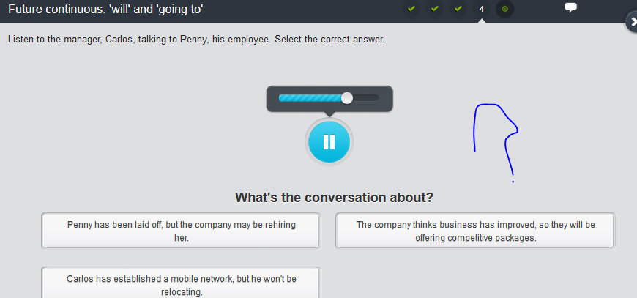

## 商业行话 business jargon['dʒɑːg(ə)n]

使用下列表达谈论人与人或企业不同部门之间的交流。注意，商业行话常常是习语。

* **就xx事情和sb接洽: touch base with sb. about sth.**   
  E.g. 我得**就**公司迁址一事**接洽**Jille.g. I’ve got to touch base with Jill about relocation. E.g. I’ll touch base with my manager about my working relocation.
* 我希望谈谈重新聘请 Tara Vang 一事。我们什么时候可以**同步交流**一下？ E.g. I wanna talk about rehiring Tracy. When can we **sync up?**
* 谢谢你让我知道。Thanks for **keeping me in the loop**
* 一个正派人/诚实坦率的人
* a straight shooter   
  e.g. She's a **straight shooter**. Even during the **layoffs**, she told the complete truth. 她是个正派人/诚实坦率的人。就连裁员的时候，她都实话实说。 E.g. I’m a straight shooter.
* 背着sb做了什么 (指秘密的行动或背叛): do something behind sb’s back. E.g. 她的助手**背着**她取消了会议 Her assistant canceled the meeting **behind her back** e.g. Don’t trust him. He’ll go **behind your back**.
* 背后中伤sb. (背后补刀) stab sb in the back e.g. 他背后中伤我，然后跟我说会做出**补偿** e.g.He **stabbed me in the back** and then said he'd **make it up to me.** e.g. Our friendship ends, and I said “How can you **stab me in the back**? You’re my bosom friend”
* E.g. Rob 把那个项目彻底搞砸了 Rob really **screwed up** that project. 使用 **screw up** 谈论他人的错误。它们语气非常强烈，可能显得无礼，因此务必谨慎使用。
* 留意xx的变动: keep track of sth e.g. 销售团队留意客户账户的变动 The sales team **keeps track of** customer accounts. E.g. Well, I can **keep track of t**heir reports, if you would like to me do.
* (the inferior)向(the superior) 汇报 answer to sb. = report to sb.: if you answer to somebody, you report to that perosn who is normally your superior, such as your lead or manager, you normally debrief your work status or progress to your superior, especially if you have any riks. E.g. The business development manager **answers to** the COO, aka, the chief operations officer. 商务开发经理**向**首席运营官**汇报**。 E.g. Andrea has two service teams that **answer to h**er. 手下有两支服务团队**向她汇报**。
* You have to pull your own weight. 你们必须各尽其力。
* I'm going to make you an offer that you can't refuse. 我要给你一个难以拒绝的开价。

## Explaining your company's structure **解释公司构成**

基于法律和经济上的考虑，公司按照不同的方式构成。

* corporation 是指**法律权利和责任**独立于所有者或股东之外的**大型企业, normally with a board of directors董事会**。此类著名的法人公司有微软和谷歌, IBM。在公司名称后，你可能见到它的缩写形式 Corp. 或 Inc.。
* LLC（有限责任公司）与法人公司的不同在于所有者的责任。'limited liability责任'意思是公司负责的人并不负担公司全部的债务（法律）责任，而是“有限的责任”。你可能看到 Ltd.、LC、LLC 或 Co 等缩写形式。
* general partnership: 是指**所有合伙人共同**承担债务的企业。E.g. With a general partnership, liability is a big concern. 普通合伙公司,**债务（法律）责任**是需要担忧的大事
* sole proprietorship[prə'praɪətɚ,ʃɪp] 是指**只有一位所有者**的企业。

## Tapescript

* Jill, I **desperately** need your help. The IBM Cloud clients just dropped on me **out of blue**/ (suddenly and unexpectedly出乎意料的；突然的). I **barely** know anything about them.
* Well, I can **keep track of t**heir reports, if you would like to me do. //留意xx的变动
* It would be great. I know, it’s a **sustainable** housing company, but …
* Well, right, it’s a corporation with **a board of directors 董事会**. And upper management **answers to** **the board of directors**.
* 高层管理人员向董事会汇报
* OK, and headquarter**s** is in London. Am I right?
* Correct, and they have 7 overseas branches.
* Did Joey say that there would be a distribution center分销中心 in ShangHai?
* Yes, in 9 months. Anyway, the company is broken down into 7 departments, each of which is manged by the director, including marketing, operation, information services, human resources, um, sales, and um…
* Don’t worry. I can find them later. Now, is Linda our direct contact interface?
* Yes. She’s the director of sales. She’s **directly reporting/answering to汇报于** the VP of sales.
* And it’s a large company, right?
* Yes, most of them are in England, with almost 3000 regular employees **in total,** not mention the outsourcing members.
* Wow, **no wonder that** 难怪their cost looks so high, even only for operation.
* It’s **probably** because of the recent regulations. They try to do business as a **general partnership**. Just with too much concerns about their **liability**债务（法律）责任.
* I totally get it. Liability债务（法律）责任 is a huge concern for everyone **in this day and age 在当今这个年代**.

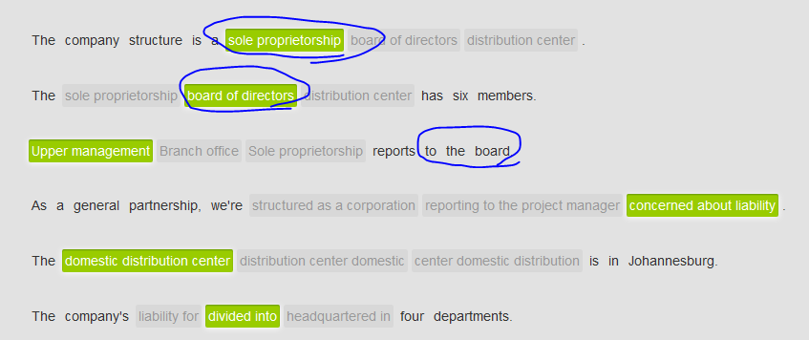

## Tapescript Explaining your company's structure

You're at a conference. You've just heard a director of sales talk about the structure at her company, CloudLife. Discuss company structure with the man sitting next to you. If you are not currently working in a company, imagine that you are.

Listen and record the correct response. When you see a blank, give true information about yourself.

* Nice to meet you.
* And you. CloudLife's an interesting company, isn't it?
* Yeah. It’s an exciting time for them. They’re working **at the forefront前沿 of** sustainable development.
* But hasn't sustainable development driven their costs up?
* **It’s said that** it’s because of their recent regulations. And the CEO said all the regulations forced them to become a **corporation**.
* That’s right. Now, where did you say you’re working?
* Well, right now, I’m working at IBM.
* It that a **corporation** or a **general partnership**?
* **Basically**, it’s a **corporation** with **a board of directors**.
* Uh ha, where are you located? The headquarter**s** or any other branch?
* We’re located in SH.
* I see. Let’s chat somewhere after this presentation. Do you have business card?
* Here you are. Let's **touch base** later.

# Group3 How to build effective teams – team work (PMP book)

## Tape script: how to build an effective business team Teamwork

You are about to watch a real-life interview with a couple who discuss how to build an effective business team. Listen for words related to building teams.

Note: The opinions expressed by the speaker(s) are not necessarily those of EF.

Keywords: communication; awards; respect all levels; everyone is for everyone else; think of as a family; with clear assignment and responsibility; have basic rules of thumb and principles; individual commitment to their tasks.

Well**, the first thing you have to do** is communication. Communication is the most important thing among all **contributing factors** to build an effective team, you know, to smoothly communicate with your employees, your colleagues, your leaders. Uh, I mean, different ideas from different people, so you want to always look for a better idea. **Ideally**, in your company, you can communicate with **all at any level. Especially** when you’re working with **younger** employees or colleagues. Listening to the young is essential because most of time the younger people do normally think in a different way. Therefore, it’s good to listen any maybe you would say “wow, let’s **incorporate** **something like that** into our project”.

Um, **additionally,** I think having a system where they have **goals**, Each one must set their goals. Well, I think it’s good for people to work together, to achieve their common purpose. Well, it would appreciate that if everyone can set their goals based on the popular SMART rule – an abbreviation for specific, measurable, attainable, realistic, time-based).

* Specific means you must have a clear, not a general goal.
* M is for measurable, which means the goal can be measured in a quantitative 定量的way and finally you would get some data or statistics.
* A means attainable, that indicates that you would get a delivered product, as a software.
* R is short of realistic and feasible.
* Lastly, T is time-based, which means every project must be done based on a limited schedule

**Well, sometimes**, people are just good at working on their own. You need to encourage them to collaborate with each other. So you wanna put these individuals together to accomplish a specific task. Um, well, we have a strong team. think we’re successful because everyone is good at a certain thing and they’re allowed to **excel发挥擅长** in that areas. Well, let’s take my project for example, it’s kind of a **daunting** task with **formidable** challenges. Then we split the project into multiple tasks, and found that every team member is good at a specific one, where they can **excel** in that area. Then it’s easier to assign tasks properly and finally committed to the success. Therefore, it’s very important to discern and distinguish everyone’s strengths and downsides, you know, their skills and weakness. Of course, we need to promote their skills. What is more, knowing everyone’s **high point** is also vital. For example, for each football team, basketball team, each player has their own job. Teamwork is critical.

**Last not but least,** you have to have principles, the **mission statement**, or **something like that**. Everyone need know what they are, their roles, and responsibilities. They must make a commitment to follow the basic principles.

Well, here comes the conclusion, in order to build a good team, based on these contributing factors, communications, setting clear goals, team work with everyone **excelling** in different areas, and following mission statement, I think we can build an effective team successfully.

## Words

* contributing factors
* quantity, quan**titative** ['kwɔntitətiv] 定量的 V.S. quality, qualitative 定性的；质的 ['kwɒlɪtətɪv]
* 发挥擅长 . Well, we have a strong team. I think we’re successful because everyone is good at a certain thing and they’re allowed to **excel**发挥擅长 in that areas. Well, let’s take my project for example, it’s kind of a daunting task with formidable challenges. Then we split the project into multiple tasks, and found that every team member is good at a specific one, where they can **excel** in that area.
* a **daunting** task = a **killer** task
* **formidable** challenges = supper big
* high point:  The high point of an event or period of time is the most exciting, most amazing, or enjoyable part of it. 高潮 (climax, peak); 最精彩部分; **(工作的) 最佳状态** [ **The high point of this concert ]** e.g. The high point of this trip was a day at the beach. 该旅途**最精彩的部分**是在海滩上渡过的一天 e.g. **The high point**高潮 **of this concert** is when the singer’s bosom friend appeared on the platform **out of blue** (suddenly, unexpected, abruptly)
* a mission statement:
* **Last but not least, 最后一点 （但并不是不重要）**
* **On that note**关于这一点

## 谈论团队协作

|  |  |  |  |
| --- | --- | --- | --- |
| **谈论团队协作** | | | |
|  | | | |
| 使用含有 **team** 的复合词谈论团队协作。 | | | |
|  | | | |
|  | Each **team member** excels in different areas. |  | 每一位团队成员各**擅**其长。 |
|  | **Teamwork** creates better results. |  | 团队协作创造更好的成果。 |
|  | We should organize weekend **team-building** activities. |  | 我们应该在周末组织一些团队建设活动。 |
|  | I need employees who are good **team players**. |  | 我需要具有团队精神的员工。 |
|  | | | |
| 使用 **incorporate** 和 **promote** 谈论建设高效团队的策略。 | | | |
|  | | | |
|  | Get ideas from your team, and **incorporate** the ideas **into** your project. |  | 在团队中集思广益，然后在你的项目中加以采纳。 |
|  |  |  |  |

|  |  |  |  |
| --- | --- | --- | --- |
|  | *We need to* ***promote*** *the team's creativity.* |  | 我们需要提高团队的创造能力。 |

|  |  |  |  |
| --- | --- | --- | --- |
| **mission statement** 传达了一家公司的主要目标，并且在其 **principles** 或 **values** 总结了公司信奉的原则或价值观。 | | | |
|  | | | |
|  |  |  |  |

|  |  |  |  |
| --- | --- | --- | --- |
|  | *To achieve our goals, we need to write a* ***mission statement*** *that clearly outlines our principles.* |  | 为了实现目标，我们需要制订公司宗旨，明确列出我们的原则。 |
|  |  |  |  |
|  | *One critical* ***principle*** *is that each employee has to make a commitment to the company.* |  | 每位员工都必须为公司作出贡献，这是一项关键的原则。 |
|  |  |  |  |
| **goal** 可分成以一系列为实现目标而设立的 **tasks**。 | | | |
|  | | | |
|  | *Before we hire a new manager, the first* ***task*** *is to write a job description.* |  |  |

* 我们提倡团队协作的原则 We **promote** the principles of teamwork.
* 安排周末团队建设活动 Organize a weekend of team-building activities.
* 尝试采纳手下员工提出的好点子Try to **incorporate**/**adopt** your employees' best ideas.
* 创建让人各展所长的任务 Create tasks that allow individuals to **excel** in different areas.
* 我们的**宗旨**表明了我们对质量的追求 Our **mission statement** shows our **commitment to** quality.
* It's critical to **promote** each individual's skills. **提升**每个人的技能至关重要。
* **On that note**, it's important that each task is clear. 就此来说，每项工作清楚明了很重要。

|  |  |  |
| --- | --- | --- |
| **不定式** | | |
|  | | |
| 用 **to** + 动词原形构成不定式结构，例如，**to make**。不定式结构可用于多种结构，表示功能或目的。例如，你可以用名词搭配不定式： | | |
|  | | |
|  | *Employees need to make a* ***commitment to succeed****.* | 员工需要致力于成功。 |
|  | *It's a* ***good idea to identify*** *each person's skills.* | 确定每个人的技能，这是不错的想法。 |
|  | | |
| 你也可以使用形容词搭配不定式： | | |
|  | | |
|  | *It's* ***good to try to incorporate*** *everyone's ideas.* | 试图采纳每个人的想法，这非常好。 |
|  | *We're* ***committed to excellence****.* | 我们致力于卓越。 |

|  |  |  |  |
| --- | --- | --- | --- |
| 用 **to + be +** 过去分词构成不定式结构，例如 **to be encouraged**。 | | | |
|  | *He* ***needs to be encouraged****, not criticized.* |  | 他需要被鼓励，而不是被批评。 |
|  | *It's* ***helpful to be engaged*** *in the process.* |  | 融入整个过程是有好处的。 |
|  | | | |
| 不定式结构可以结合使用： | | | |
|  | *Some people need* ***to be encouraged to work*** *in teams.* |  | 有的人需要受到鼓励与团队合作。 |
|  | *It's important* ***to work together to accomplish*** *goals.* |  | 重要的是，共同努力实现目标。 |
|  | | | |
| **To +** 动词起到与用于表达目的的结构 **in order to +** 动词一样的功能。**To +** 动词这种结构更常见，尤其是在英语口语中。 | | | |
|  | *Pull all the skills together* ***in order to build*** *an effective team.* |  | 集合所有人的技能，从而建设一支高效的团队。 |
|  | ***To better understand*** *your goals, you should write a mission statement.* |  | 为了更好理解你们的目标，你们应该制订宗旨声明。 |

## Mission statement

Morris Marketing Inc.  
  
Mission statement  
  
We study our clients' principles and work to incorporate those values in our marketing campaigns. We completely commit to each individual client, to serving their needs and delivering excellence. We believe that cooperation and teamwork help us achieve all of our goals and dreams.  
Morris Marketing Inc.

## Tapescript

You are one of two leaders on a big, new team project. Brainstorm with Kayla, the other leader, about building an effective team.

* Well, we’re pretty strong team, but I have few concerns with Nicolas. He’s one the best players in our team. However, in fact he prefers to work alone.
* Perhaps he needs to be encouraged to work with someone he likes.
* Yeah, but who does he like. But frankly, I don’t think anyone in our team really becomes friendly. It might be a good idea to find some time to play outside of work for them to socialize, a dinner, a weekend-outing, etc. You know, work hard, play hard.
* Allow the team to get to know everyone better.
* Exactly. We need to figure out everyone’s individual personality and character. Just find out what they do best, so that when they’re working, just allow them to **excel** in that area.
* I agree. It's a good idea to **promote** each team member's unique skills and allow them to **excel** in different areas.
* Right, so what some of other strategies for me to make the team more effective. Well, the 1st thing is to encourage them to do good communication.
* One of the ways to do that is to use email and blogs.
* A blog. That’s a cool idea. We should be always looking for a better way to achieve our goals
* **On that note**关于这一点, it's also critical that each goal is clear.
* One way to do that may be to post it around office?
* Or we'll blog about a different task each week. Maybe we can invite the team to comment.
* I like it.
* Great! I think we made a good start here.

## Brainstorm idea

Three colleagues are brainstorming ideas.

KEN: OK, everyone. Let's try to **think of** some different ways to work on the Edmonds project. Amy, **can you start?**

AMY: Sure. First, I think we need to **figure out** what everyone does best, in order to allow each person to do what they're good at.

KEN: Right. And we also have to make sure people cooperate together. Uh, Bill**? Any thoughts?**

BILL: Um, I think we need to know people's individual skills and encourage teamwork. I'm totally into designing some fun weekend activities that would help people learn to work together to accomplish goals.

KEN: Right. I agree. It's important to encourage teamwork. OK. **Any more ideas?** Okay, then. Uh, great meeting, everyone.

## Tips for success at work

**Seven Tips to Build an Effective Team**

You probably either lead a team or work on a team, but do you know how to build an effective team? Too often, a team is weak and a project fails because each individual thinks only about himself or herself. If you build an effective team instead of working individually, more innovative, satisfying results can be achieved.

Here are seven tips for building an effective team:

**Select a Good Leader**

Choose someone who is an **impressive/charismatic** manager and an excellent communicator, as well as someone who has strong skills appropriate to the project.

**Just Say 'Yes!' to the Project**

Discuss the project together as a team. Allow the team to brainstorm and ask questions. Try to **incorporate** their ideas **into** the project, and then ask team members to sign a contract saying they **are committed to the success** of the project.

**Make Goals Clear**

Write them down. Email them to all involved person and always keep everyone in the loop. Post them on the wall. Text, blog and talk about them throughout the project. Establish a contest, and reward people for showing how they've achieved a task.

**Promote Skills**

Each project has many different tasks; each team member has a different and unique set of skills. Discover what each team member can do, assigning them to the appropriate task and allow to **excel** in different areas. Together, you'll have a full skill set that can be used to expertly complete every task on the project.

**Work Together**

Although each person has unique skills, everyone should cooperate on the project. Encourage people to work with one another, instead of solely on their own, by pairing them and requiring that they accomplish a specific task together. Teamwork pays off!

**Communicate**

Did I mention team members should talk to one another? As the project continues, discuss what's already been accomplished. Describe problems you're experiencing and how to solve them; you can always find a better idea, a better way of doing things. Use project management software to keep everyone informed.

**Work Hard, Play Hard**

Find ways after work to socialize, such as eating dinner together or a week away for team-building activities and games. Socializing helps team members get to know one another better so they can anticipate everyone's actions and needs on the project.

Put these seven top tips into practice, and you'll find your team is functioning more effectively and working together more happily. Good luck!

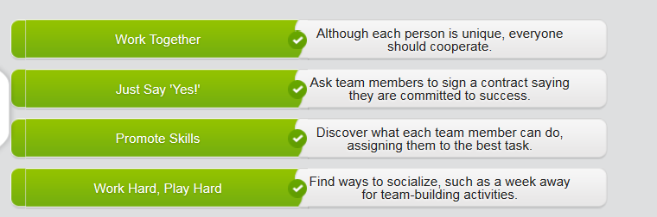

# Group4 Management strategies

## Prerequisite: review PMP book ahead of time

|  |  |  |  |  |
| --- | --- | --- | --- | --- |
| Plan | Design | Carry out | Check/Assure | Ending |
| SWOT  SMART  Mission statement | All persons are on the same page  Excel in different area, but working as a team | Communication  Scope & schedule & cost |  | Team building  Retrospective meeting |

## Tapescript

Well, first of all/the No.1 thing is, I just wanna tell that I think the people in the most aspect for our company. That’s why I’d like to **assume** you as the director of HR department, to lead the intern program.

Intern program? Well, I can do that.

Great, I’m glad to hear that. Furthermore, I feel that ever new employee that comes in should ave a comprehensive **induction** (or induction training)

Like my **induction / induction training**?

Well, I think … Um, we’ve learned from mistakes. (The manager is so awkward/embarrassed)

Um…it sounds expensive.

Ture, it’s expensive. But we’re expanding and expansion is always expensive. But I think we’ll benefit pretty soon. We’ll have employees who will make less mistakes, and communication skill would be better.

How about the company organization that I would be responsible for, I mean, restructure.?

Well, **as I was saying**, communication is a key element here. I’d like the managers to be clearer on who they should report to**/answer to**. And we must make sure that our creative teams, our design, and business management, are all **on the same page**. Another easier solution would be weekly **managerial  [mænə'dʒiːrɪəl]** meetings.

I want all headers of department to discuss the short-term and long-haul goals, with appliance with SMART rule obviously. Uh, maybe even have managers have a forum to discuss their problems with each other.

You were just speaking earlier about clearer communication, but all I’ve heard so far is nothing but an insane amount **of vagueness [veɪɡnəs] 糊；含糊**；.

That’s what I always appreciated about you … your honesty.

I think you have some great ideas, but where you lack is in details and structure, in both areas of which **I excel at.**  …. Well, What I expect is to come back to work “with you”, but not “for you”. I want to **assume the role as** VP of xxx department, I want responsibilities, making decision in the room.

## Words

|  |  |  |
| --- | --- | --- |
| *Finding solutions to problems is the most* ***important aspect*** *of good management.* |  | 找到问题的解决办法是优秀管理最重要的内容。 |
| *Identify the* ***key elements*** *important to achieving a goal.* |  | 确定对实现目标非常重要的关键因素。 |
| *Develop* ***mutual trust*** *with your employees.* |  | 在你的员工之间培养互信。 |
| *Consider the* ***internal*** *and* ***external threats*** *to a project.* |  | 考虑项目受到的内部和外部威胁。 |

* toss ideas around 讨论 = discuss
* **excel at**
* **assume the role as**
* **managerial  [mænə'dʒiːrɪəl]**
* 入职培训；就职培训 induction, induction training
* SMART: specific, measurable, attainable, realistic, time-based
* SWOT: strength & weakness/downside; opportunities & threats
* PMP bible:

|  |  |  |  |
| --- | --- | --- | --- |
| 下一种词组是名词 **+** 名词。 | | | |
|  | | | |
|  | *Please read the* ***terms and conditions*** *of the contract.* |  | 请阅读合同的条款和条件。 |
|  |  |  |  |
| 这些词组均包含动词。前两个词组是动词 **+** 名词，第三个词组是动词 **+** 动词。 | | | |
|  | | | |
|  | *This will help* ***encourage expansion****.* |  | 这将有助于推动扩展。 |
|  | ***Carry out an analysis*** *of strengths and weaknesses.* |  | 开展一项优缺点的分析。 |
|  | *Employees must* ***be willing to commit*** *to the plan.* |  | 员工必须愿意为这项计划而努力。 |

**An important aspect of management** is creating a positive culture.  
  
What are the **key elements** for achieving your goal?  
  
It's important to develop **mutual trust** with your employees.  
  
Can we avoid internal and external threats to the project?  
  
A positive corporate culture helps encourage expansion.  
  
**Carry out a**n analysis of strengths and weaknesses involved in a project.

|  |  |  |  |
| --- | --- | --- | --- |
| **提出管理策略的建议** | | | |
|  | | | |
| 使用含有 **be**、**need** 或 **say** 等词的表达，提出你坚信或确信的建议。 | | | |
|  | | | |
|  | *Mutual trust* ***is*** *a key element.* |  | 相互信任是关键因素。 |
|  | *An easy solution* ***would be*** *to hire a new project manager.* |  | 一种简单的办法是聘请一位新的项目经理。 |
|  | ***We need to be sure*** *managers are on the same page.* |  | 我们需要确认各位经理达成共识。 |
|  | ***I say*** *we require that departments communicate more frequently.* |  | 我认为，我们应该要求部门之间的交流更加频繁。 |

|  |  |  |  |
| --- | --- | --- | --- |
| 使用类似表达**提出更犹疑的建议**： | | | |
|  | | | |
|  | ***My thought is to*** *encourage expansion by creating a richer corporate culture.* |  | 我的想法是通过建设更加丰富的公司文化来推动扩展。 |
|  | ***We could maybe even have*** *a forum.* |  | 也许我们甚至还可以举办一次讨论会。 |
|  | ***What if we*** *carry out an analysis?* |  | 要是我们开展一次分析会怎么样？ |
|  | ***I'd like to*** *analyze the internal and external threats first.* |  | 我想先分析一下受到的内部和外部威胁。 |

|  |  |  |  |
| --- | --- | --- | --- |
| 你可以使用含有 **propose** 和 **suggest** 的表达来提出建议。 | | | |
|  | | | |
|  | *I* ***propose*** *that, just one day a week, we don't have any meetings.* |  | 我提议，每周空出一天不开会。 |
|  | ***What I'm proposing is*** *that we incorporate employee feedback.* |  | 我建议我们应该采纳员工的反馈。 |
|  | *I say we use instant messaging more often –* ***just a suggestion****.* |  | 我认为我们多多使用即时讯息，只是提议一下。 |

## (not finish) Tapescript – “No phones in the meeting policy”

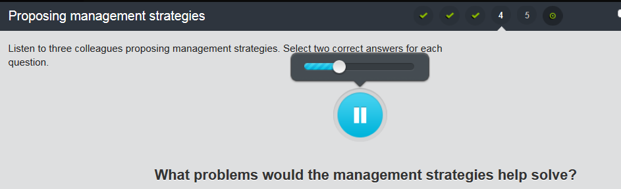

## Reading

Hi, all.

As the executive team, we all think a lot about effective and innovative ways to prevent and solve business problems. I'd like to toss around a few ideas and perhaps propose some additional management strategies for some of the specific issues we're experiencing.

First, I'm sure that we're all very familiar with Albert Humphrey's SWOT analysis, the management-strategy process where managers evaluate a project's strengths, weaknesses, opportunities and threats (SWOT). However, I'm also very aware that we haven't ever used it here. Perhaps everyone is just too busy, but I think we can really learn a lot from SWOT. What I'm proposing is that we try SWOT as we begin the Cre8or Software project. For example, what if we carry out a SWOT analysis and include it in the written proposal for Cre8or? I think Cre8or would very much appreciate knowing about the internal and external elements that might threaten their business, and which elements could be opportunities. There may be similar software already in development, or maybe there's a product that's full of holes that Cre8or could improve on.

Second, we've been talking a lot about expanding the business. In order to encourage expansion, I think we need to develop a greater feeling of mutual trust between employees and managers. What I'm proposing is that we be willing to allow employees to take on greater responsibility; we should be willing to allow them to make more decisions. The more we can trust our employees to perform certain tasks without supervision, the more upper management can devote to expansion and profit strategies.

Third, I'd like to bring up the issue of our work environment here at the office. I think we all feel that our day is full of interruptions and distractions – meetings, phone calls, nearby discussions between colleagues or even a tap on the arm. Although collaboration is valuable, I think we may all need some quiet time to focus on our work and be creative. My thought is to schedule some time where we don't have meetings, formal or informal, so that we can all just get work done. Maybe we could even have a 'no-meeting' day that's devoted to each individual working alone, uninterrupted, undistracted. Just a suggestion.

Sorry for the long email, but I wanted to get us all on the same page, thinking about more effective management techniques. I very much value your feedback on these ideas and would like to hear your ideas, too.

Best regards,

Cam

## Writing

Write a short text proposing **effective management strategies**. You can propose strategies to help manage a specific business issue, or you can propose general management strategies that help create a successful business or project. Explain why your proposals would be effective.

Type in the input box. Write 150-200 words.

To create a successful project and solid teamwork, the first thing you have to do is to set clear goals from high-level point of view. I highly propose that companies can try the SMART principle that helps every team member to create clear goals and finally achieve their common target. SMART is an abbreviation for specific, measurable, attainable, realistic, and time-based. It indicates that a clear goal must be realistic and feasible. Moreover, it can be achieved by producing a deliverable output by a predefined deadline and must be measured by using a quantitative method.

My thoughts would then take SMART even further. From SMART, manager can have a hint about which fields that each member is good at so that manager should encourage everyone to excel in different areas.

SMART principle can actually work through the whole project development life cycle and should be agilely fine-tuned to quickly fit any changes from markets. Furthermore, based on SMART, all team members should stand on the same page, which is one of the most important contributing factors to build a successful project and solid teamwork.

## Writing sample

To create a successful project and solid teamwork, I propose that companies use the SWOT analysis technique. SWOT help a business evaluate internal and external strength & weakness and opportunities & threats. Let’s say you carry out a SWOT analysis at the beginning of a project.

The No.1 thing you have to do is to make sure that project goals are clear, which should be exactly documented in the mission statement. Then, I’d say that you should make a list of questions to satisfy each element of the SWOT analysis. You want to make sur all the major project tasks are covered and identify possible risks.

My thought then would be to take SWOT even further. Team members could collaborate on a SWOT analysis of the team itself, making them a stronger team and developing mutual trust. For example, if the team spends time identifying their strengths, then the resulting information can actually motivate the team. And, as they identify weaknesses, they become more aware of how to prevent future problems.

Once you complete a SWOT analysis, I suggest that you review it frequently. Change the questions and answers as the market changes, and focus on taking advantages of your strengths and opportunities, and reducing your weakness, and even avoiding threats and risks.

# Writing

**=> Consider SWOT: strength V.S. weakness; Opportunity V.S. threat (like a coin with two side, pros and cons; advantages V.S. downsides)**

# CNN topics